**List Family Pictures Follow**

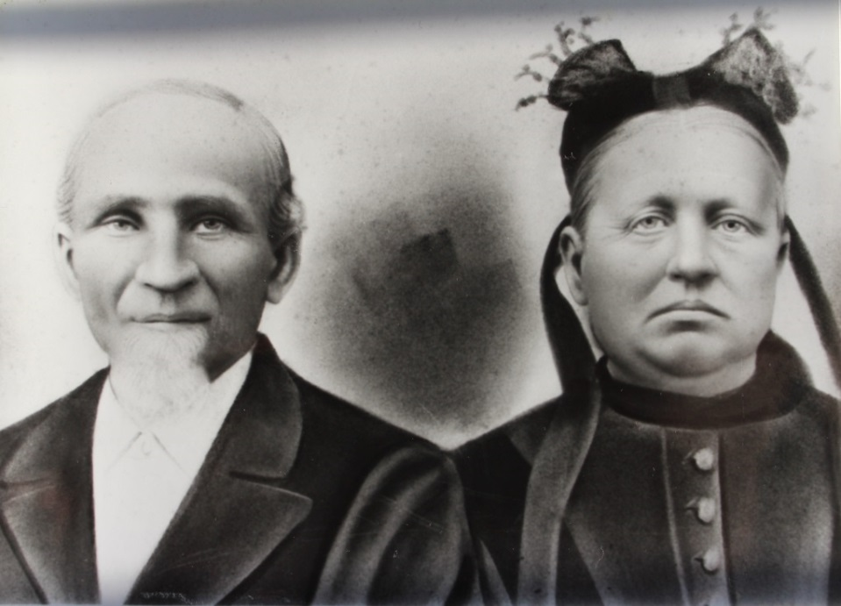

John P. List and his wife, Sophia Clouse List – about 1900 (est.)

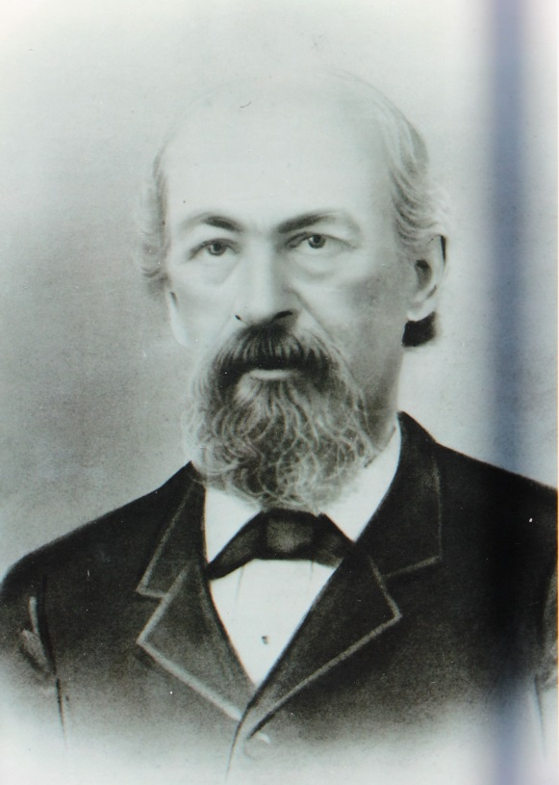

Philip Kern, father of Maggie Kern

and grandfather of Luther J. List – about 1905 (est.)